Laporan Praktikum 3

1. Source Code

matakuliah.php => controllers

view-data-matakuliah.php => views

view-form-matakuliah.php => views

1. URL

<http://localhost/pustaka_booking_rina/matakuliah/>

<http://localhost/pustaka_booking_rina/matakuliah/cetak>

1. Capture Output Program

Form Input Mata kuliah

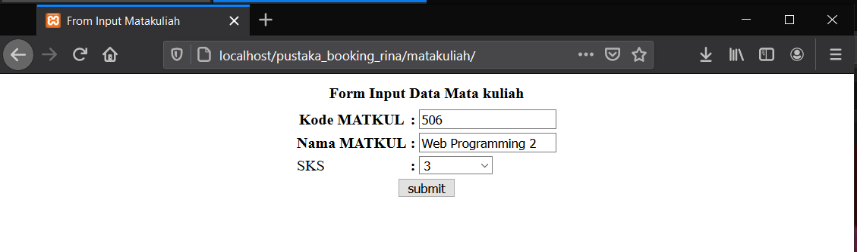

Tampil Mata kuliah

